# How to Generate the BRIDG reports for the Release package

## Doc Report

1. Select the highest level package in the Browser – BRIDG Domain Analysis Model
2. Right click > Documentation > Generate Documentation
3. Make the selections as seen the screen shot below
   1. The BRIDG 4.0 report took about 22 minutes to generate with these selections
   2. Although “Include Diagram…” was not selected, the report had all the diagrams
   3. Generating the report as MS Word appears to be a faster report than RTF

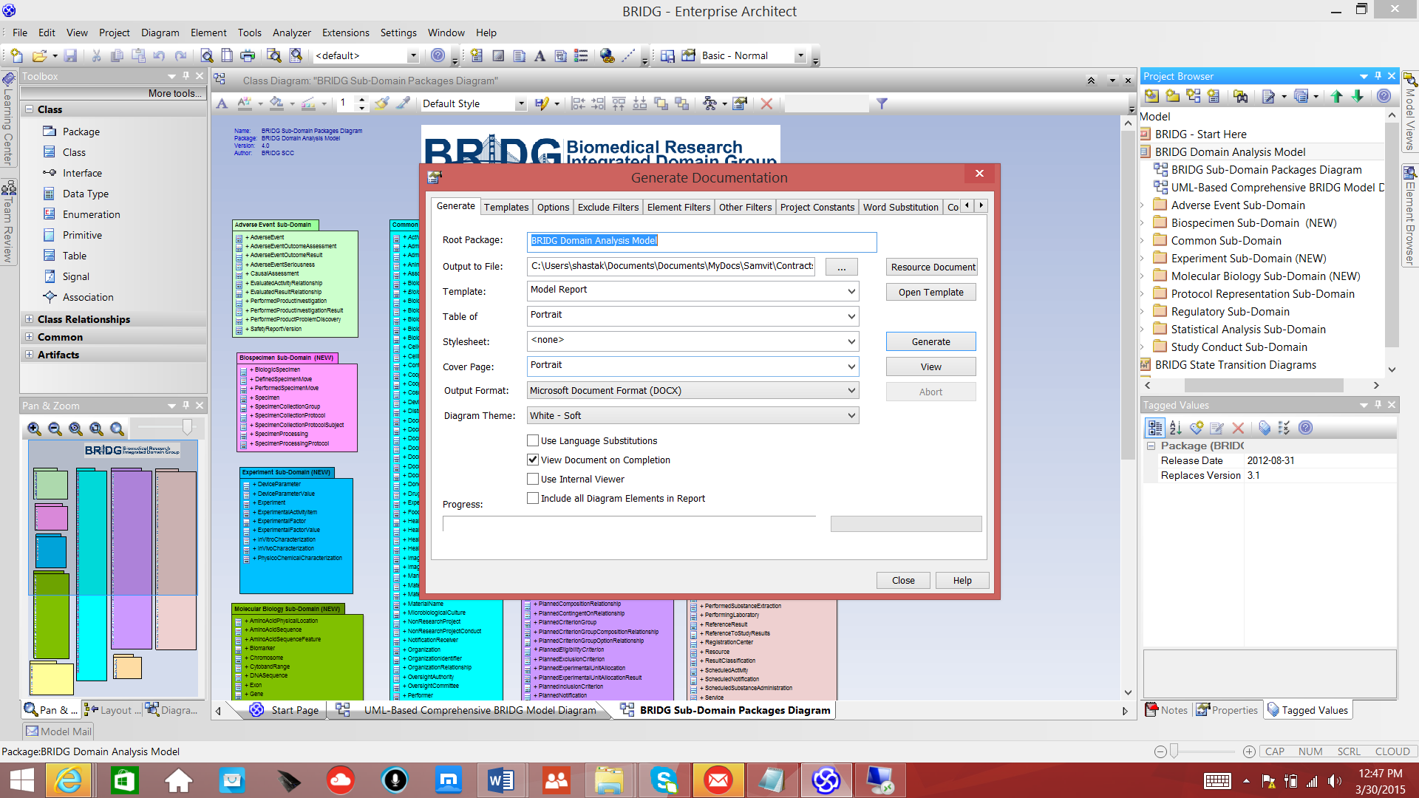

## HTML Report

1. Select the highest level package – BRIDG Domain Analysis Model
2. Right click > Documentation >HTML Report
3. Make the selections as the screen shown below
4. Takes about 5 minutes to generate –
   1. file is very large and cannot be sent to web team in email
   2. Create a shared folder thru File Share app

